**PROBLEM:**  Consider the grid of hexagons shown at the right. The grid extends upward infinitely and to the right for 26 columns. 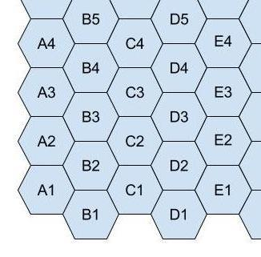

One can move from cell to cell across the borders of the cells. The direction of the move is given by the numbers 1 through 6 as shown below:

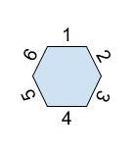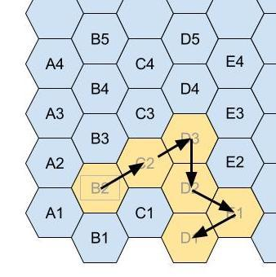

For example, starting at B2, the path 22435 would end up at cell D1: B2 to C2 to D3 to D2 to E1 to D1. See the diagram at the right.

In this program, you will be given a starting location and a sequence of moves, you need to report the ending location. If a move would take you off the grid, ignore that move, but continue to process the remaining moves in the sequence.

**INPUT:** There will be 10 linesof input. Each line will contain two strings. The first string *s* is the starting location. It is a letter (A through Z) followed by a number. The second string *m* contains a series of digits representing the moves (each move is a number 1 through 6). String *s* will be fewer than 8 characters long, and string *m* will be fewer than 64 characters long.

**OUTPUT:** For each line of input, print the final location after the moves have been made, as described above.

**SAMPLE INPUT**

B2 22435

C4 22435

D6 54166231

E5 162435

E5 162435534261

M5 123123123123

G9 3

G9 1

B2 6163

B2 3251616544

**SAMPLE OUTPUT**

1. D1
2. E3
3. C7
4. E5
5. E5
6. U9
7. H9
8. G10
9. B3
10. A2

**TEST DATA**

**TEST INPUT TEST OUTPUT**

D4 123456 1. D4

E3 654321 2. E3

K7 63165 3. I8

E4 44454456445 4. B1

E4 444544564454334 5. B1

C5 51515151 6. A8

X8 34343434 7. Z3

M9 121 8. N12

K37 233245 9. N36

G123 54342125654345432123452 10. J118